

Name: Amol Dnyaneshwar Wadhekar

Reg.No:2018bec098

Roll No:B-52

Sub:DSP

**Title : Sampling theorem**

**Aim**: To study the sampling theorem and effects of under sampling, exact sampling and oversampling.

**Tool**: Matlab R2020b

**Theory:**

Sampling theorem specifies the minimum  sampling rate at which a continuous time signal needs to be uniformly sampled so that original signal can be completely recovered or reconstructed by these sample alone.

Discrete time sequence is developed by uniformly sampling a continuous time signal. The time variable t of continuous time signal is related to time variable n of discrete time signal only at discrete time instants. Identical discrete time sequences may result from sampling of more than one distinct continuous time functions. There exists infinite number of continuous time signals, which when sampled lead to same discrete time signal .However it is possible to relate a distinct continuous time signal with to given discrete time signal and to recover original continuous time signals from sampled values.

**Effect of sampling in frequency domain:**

Let $g_{a}(t)$ to be a continuous time signal that is sampled uniformly at t= nT , generating the sequence $g[n]$ where

$${g\left[n\right]=g}_{a}\left(nT\right) , -∞<n<∞$$

with T being sampling period .The reciprocal of T is called sampling frequency FT The frequency domain representation of $g_{a}\left(t\right)$ $is given by its continuous time Fourier Transform$ [CTFT] $G_{a}(jΩ)$. Whereas the frequency domain representation of $g[n]$ is given by its discrete time Fourier transform [DTFT] $G(e^{jw})$. To establish the relationship between $G(e^{jw})$ and $G_{a}(jΩ)$,sampling operation mathematically treated as multiplication of continuous time signal $g_{a}\left(t\right)$ and periodic impulse train $p\left(t\right)$ denoted by $g_{p}(t)$,

$p\left(t\right)=\sum_{n=-∞}^{n=∞}{δ\left(t-nT\right)}$

Frequency domain representation of $g_{p}(t)$ is given by ,

$$G_{p}\left(jΩ\right)=\frac{1}{T}\sum_{k=-∞}^{k=∞}{G_{a}(j(Ω-kΩ_{T}))} (1)$$

Therefore $G_{p}\left(jΩ\right)$ is a periodic function of $Ω$ consisting sum of shifted and scaled replicas of $G_{a}(jΩ)$.In equation 1 ,for k=0,the term on the right hand side is baseband portion of $G_{p}\left(jΩ\right)$.The frequency range $-\frac{Ω_{T}}{2}≤Ω≤\frac{Ω_{T}}{2}$ is called baseband or Nyquist band. Let $Ω_{m}$ be maximum frequency of signal. ${2Ω}_{m}$ is called nyquist rate.

1.If $Ω_{T}>2Ω_{m}$,there is no overlap between replicas of $G_{a}\left(jΩ\right)$ generating $G_{p}\left(jΩ\right)$ and $g_{a}(t)$ can be recovered from $g_{p}\left(t\right)$ by passing it through an ideal low pass filter. Also called as oversampling that is sampling signal at frequency greater than nyquist rate.

2. If ,due to overlap of shifted replicas of $G_{a}\left(jΩ\right)$ and cannot recover $G_{a}\left(jΩ\right)$ by filtering. This is also called as aliasing. This is called undersampling that is sampling signal at frequency lower than nyquist rate.

3. If ,This is called criticalsampling that is sampling signal at frequency equal than nyquist rate.

**Sampling theorem:**

Let $g_{a}(t)$ is band limited signal with $G_{a}\left(jΩ\right)=0 for \left|Ω\right|>Ω_{m}.$ Then

$g_{a}(t)$ is uniquely determined by its samples $g_{a}\left(nT\right),-∞<n<∞,$ if $${ Ω}_{T}≥2Ω_{m} … (2)$$

where $$Ω_{T}=\frac{2π}{T}$$

Equation (2) is called as Nyquist Condition.

Also, $Ω_{m}<{ Ω}_{c}<(Ω_{T}-Ω_{m})$ where $Ω_{c}$ is cutoff frequency of lowpass filter.

**Question**: WAP in MATLAB to implement the sampling theorem and observe the effects of different sampling frequency on real life Analog signal.

Example: Generate the input signal which consists of sinusoidal signal with two frequencies 3Hz and 8Hz. Initially plot the continuous time input signal with its frequency spectrum. Plot the given input signal for each case (under sampling, exact sampling and oversampling) and its frequency spectrum.

**Output**:

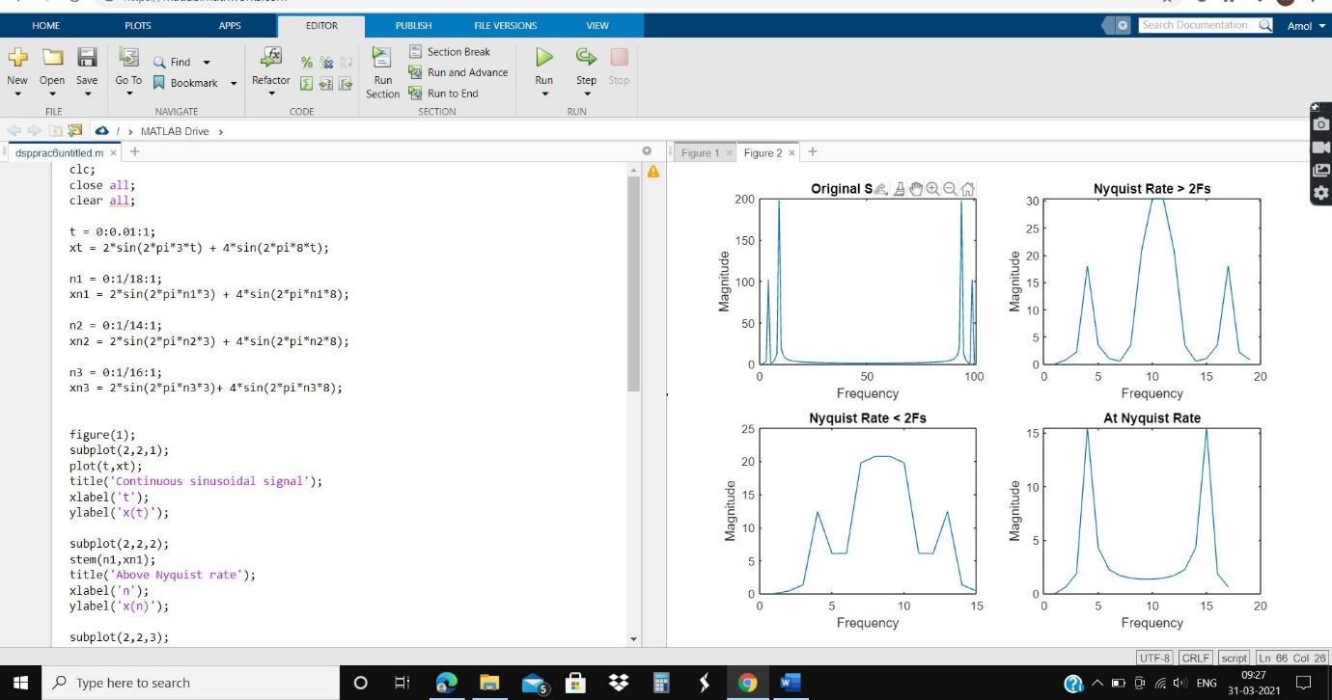

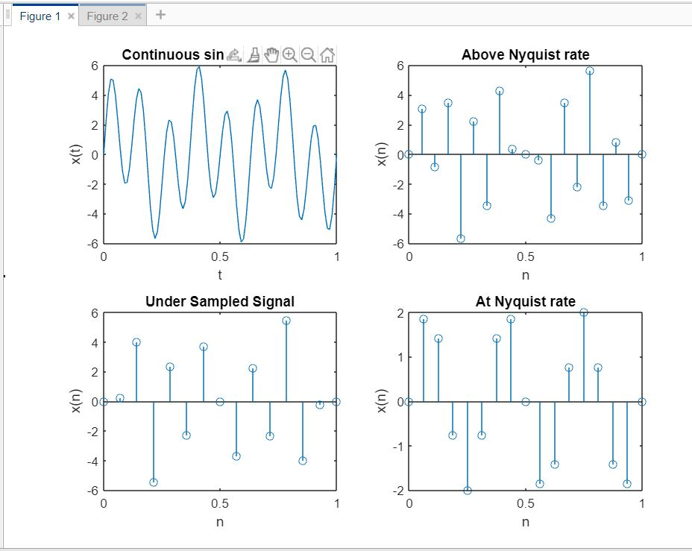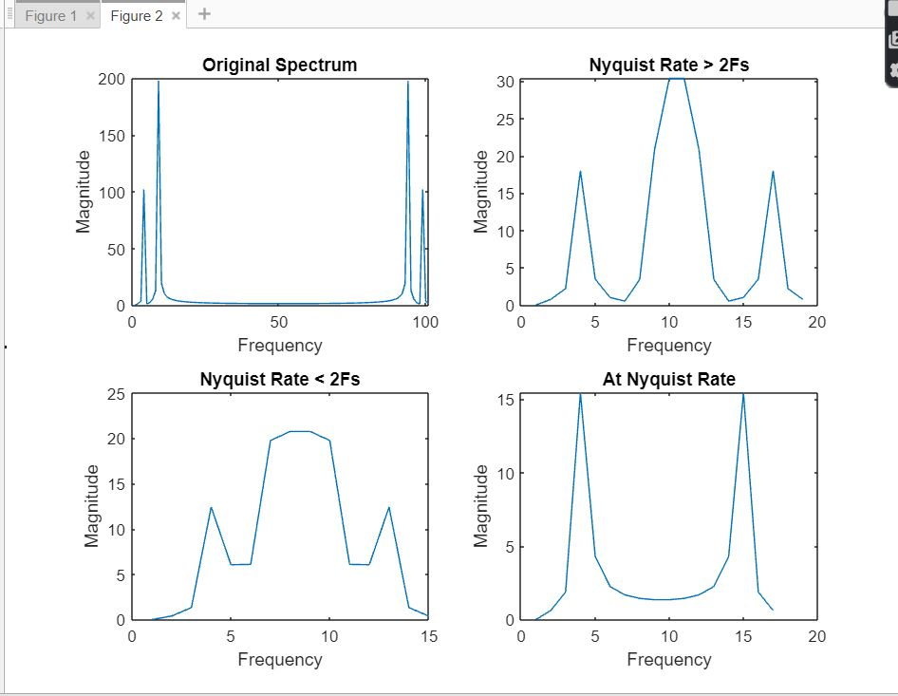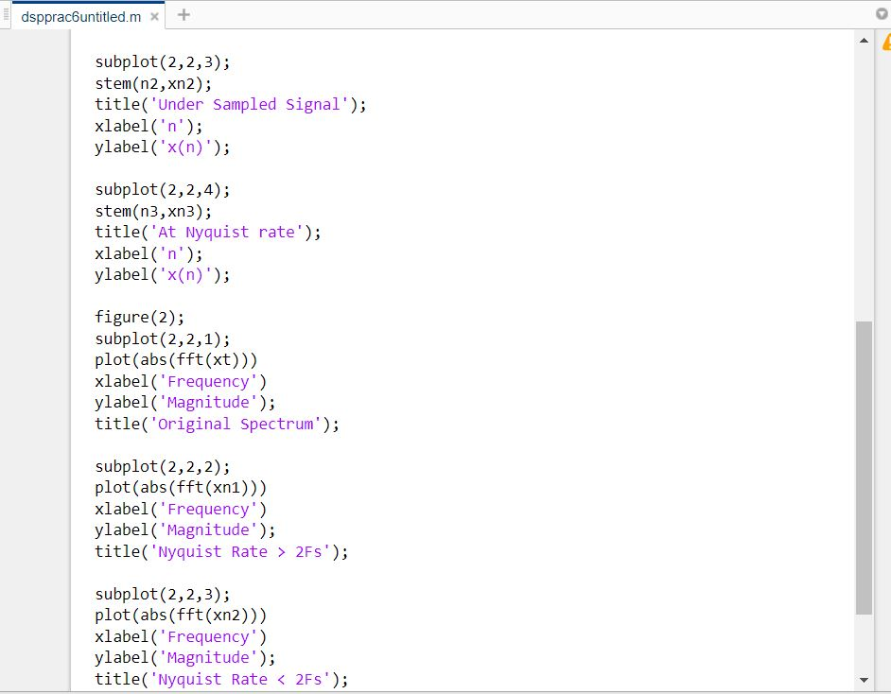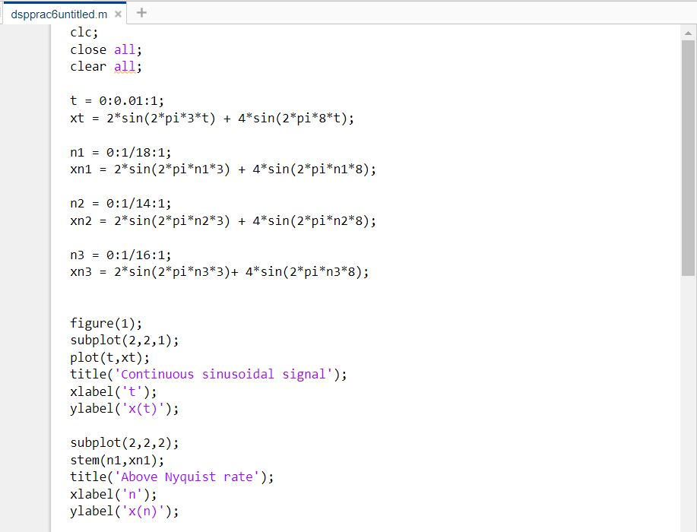

**Conclusion:**

The theorem implies that there is a sufficiently high sampling rate at which a bandlimited signal can be recovered exactly from its samples, which is an important step in the processing of continuous time signals using the tools of discrete time signal processing.